EXPERIMENT - 1
ROLL NO:240701051
NAME: ARUNPRANESH ES
USER INTERFACE DESIGN
Comparison of UI Design between two Figma creation

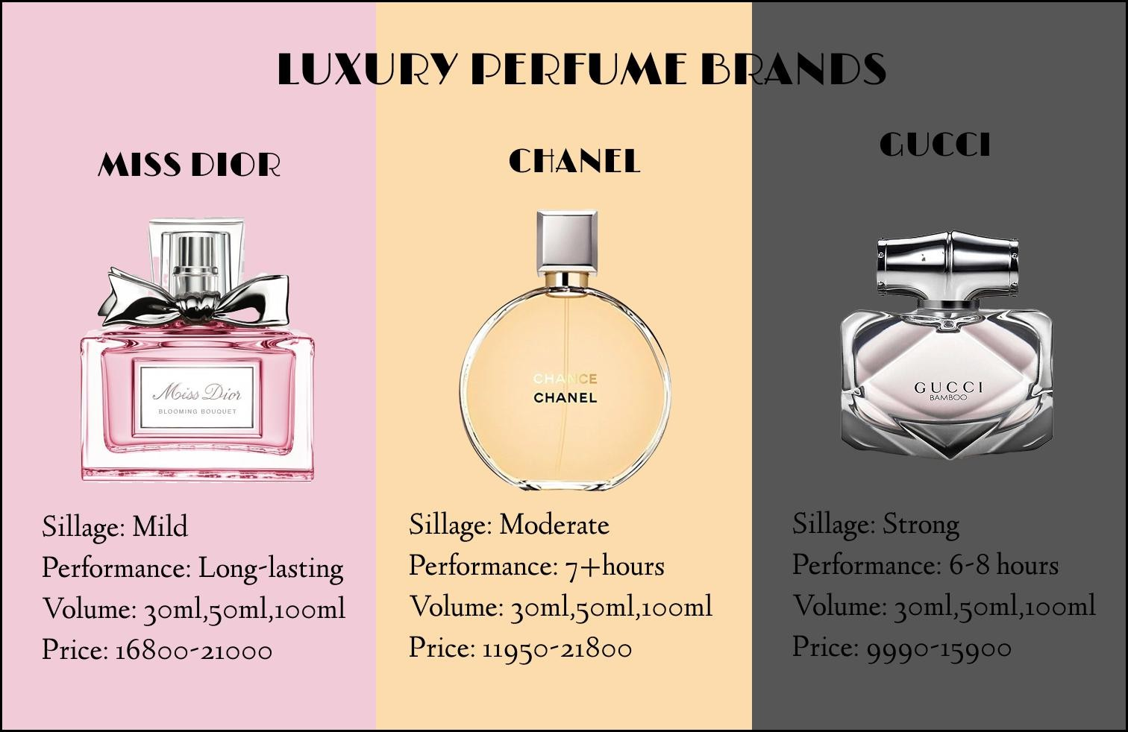
Bad Website:

Good Website:

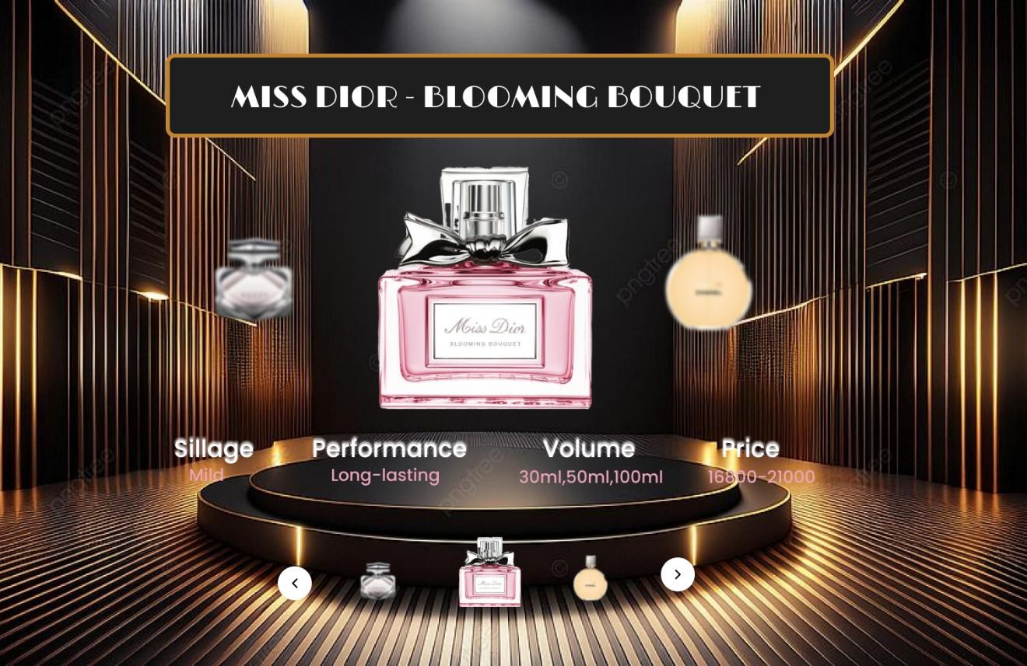

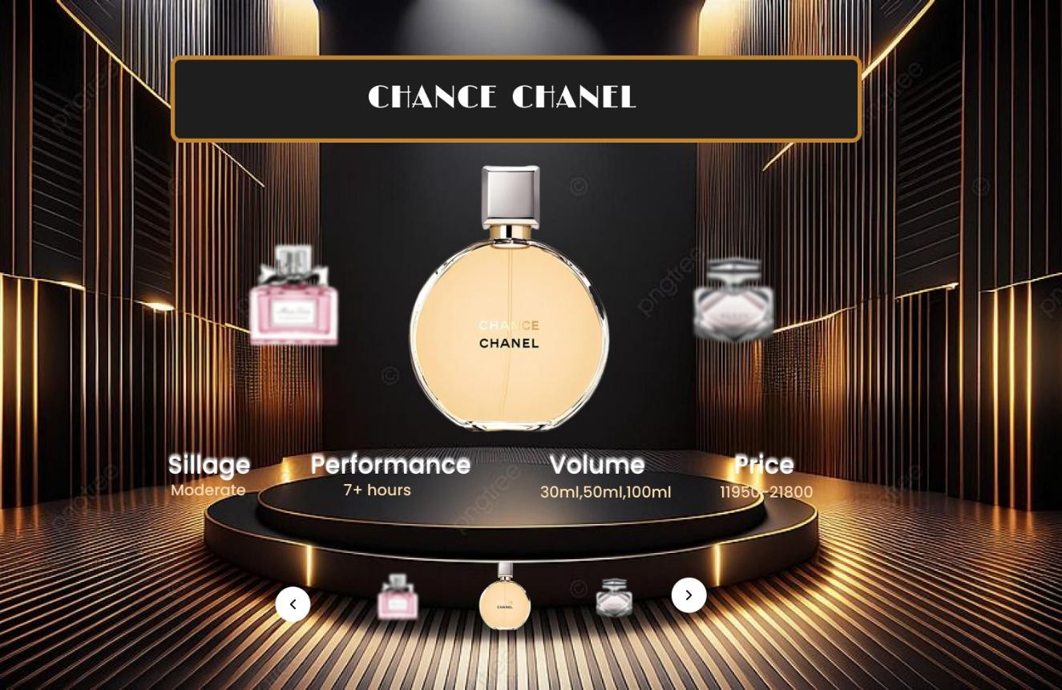

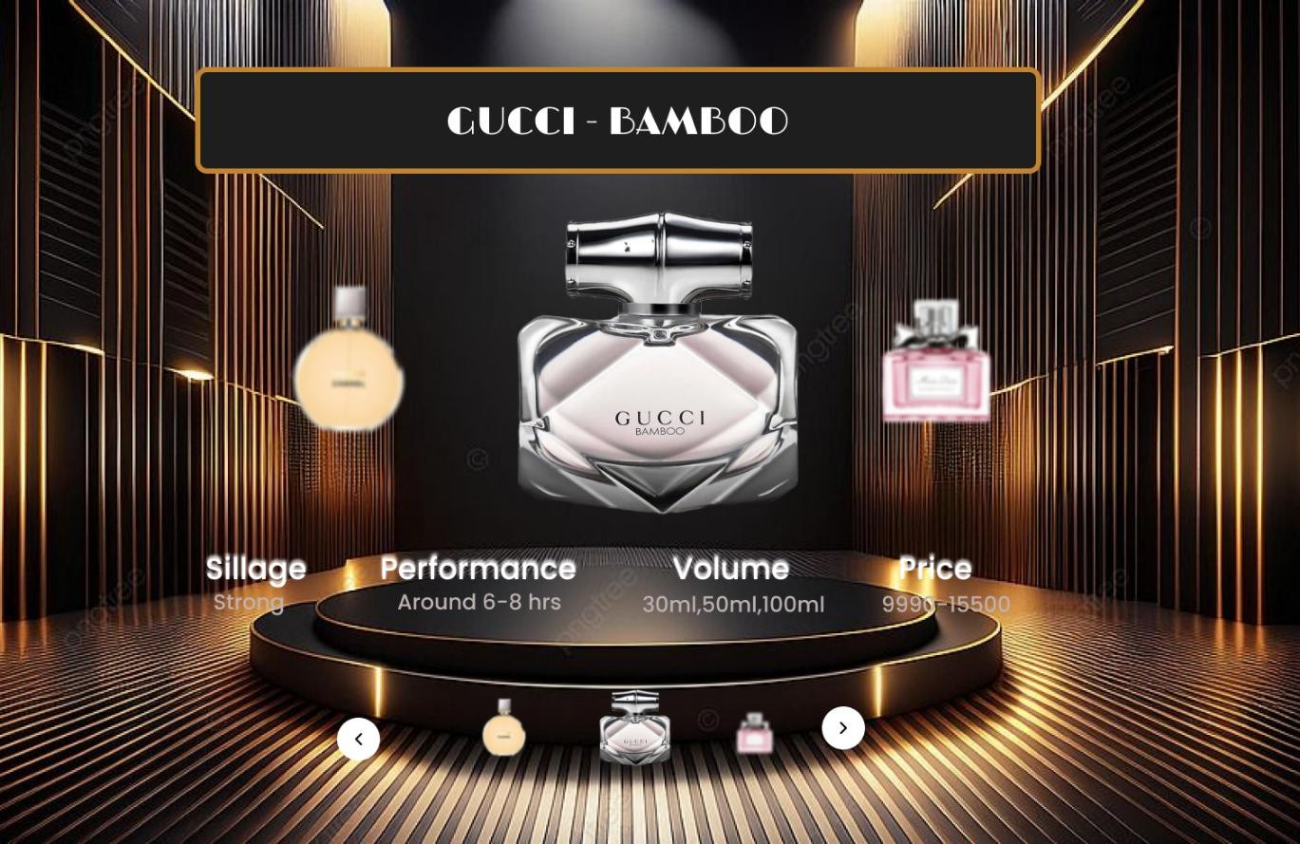
PROTOTYPE LINK:
https://www.figma.com/design/wUjzCnT7mUV4GY0t5j7ILL/UID-EXP-1?node-id=0-1&t=lhYfnTtqSxxdHsdn-1
The two website have distinct designs and approaches. Here’s a comparison:

BAD WEBSITE (Luxury Perfume Brands)
- Design Style:
  - Simple and static layout with minimal visual hierarchy.
  - Uses flat background colors for each brand section without depth or interaction.
  - Lacks premium feel despite showcasing luxury brands.
  - Typography is plain and does not strongly reflect a high-end aesthetic.

Content:
  - Displays basic perfume details such as sillage, performance, volume, and price.
  - Information is text-heavy and repetitive across all products.
  - No storytelling or emotional connection to the brand or fragrance.
  - Lacks engaging elements like highlights, offers, or descriptions.

Navigation:
  - No visible navigation elements or interactive controls.
  - Users cannot explore individual perfumes in detail.
  - Feels more like a static poster than a functional website.

Purpose:
  - Primarily focused on displaying product information.
  - Suitable only for basic comparison, not for engagement or conversion.
  - Does not encourage user interaction or exploration.

GOOD WEBSITE (Miss Dior – Blooming Bouquet & Others)
- Design Style:
  - Visually rich and premium design with a luxurious theme.
  - Uses depth, lighting, shadows, and 3D-like elements to enhance realism.
  - Strong visual focus on the selected perfume with a stage-like presentation.
  - Color palette and layout match the elegance of the brand.

Content:
  - Key perfume attributes (sillage, performance, volume, price) are clearly highlighted.
  - Information is well-organized and easy to scan.
  - Supports multiple perfumes using a carousel-style layout.
  - Focuses on showcasing the product as a hero element.

Navigation:
  - Includes interactive navigation controls (left/right arrows).
  - Allows users to browse through multiple perfumes smoothly.
  - Encourages exploration without overwhelming the user.

Purpose:
  - Designed for product showcasing and brand experience.
  - Creates an emotional and premium connection with users.
  - Suitable for luxury branding, promotions, and product marketing.

Key Differences:
Focus:
The bad website is information-centric, while the good website is experience-centric.

Design Aesthetics:
The bad website feels flat and basic; the good website feels luxurious and immersive.

User Engagement:

The good website encourages interaction and exploration, whereas the bad website does not.

Brand Value Representation:
The good website successfully reflects luxury branding; the bad website underrepresents it.

